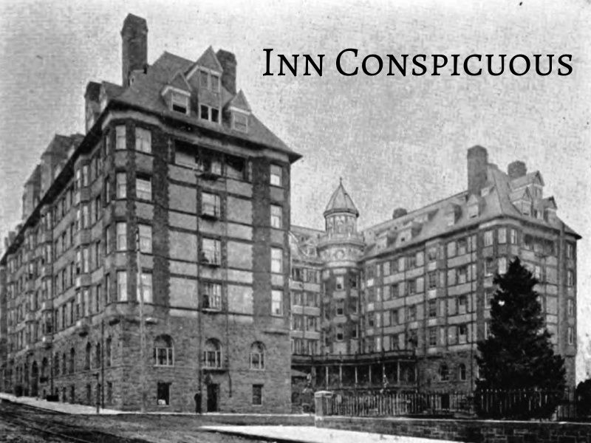

Game Design Document v0.x

# Introduction

Inn-Conspicuous is a massively multiplayer online role-playing game (“MMORPG”) about a hotel for cryptids: mysterious creatures from urban mythology. Explore the hotel, solve puzzles, fight monsters, and work with other players to unravel the mysteries and rise the ranks of Inn Conspicuous!

## Table of Contents



1.0 Introduction 1

1.1 Table of Contents 1

1.4 Game Summary 3

2.0 Story and World 4

2.1 Plot 4

2.2 Story Summary 4

2.3 World and Locations 4

2.3.1 List of Locations Appearing in the Game: 5

2.4 Characters 5

2.4.1 Summary 5

2.4.2 Player Characters 5

2.4.3 Boss Cryptids (Guest-type) 5

2.4.4 Recurring Cryptid NPCs 6

2.4.5 Common NPCs (Pest-Type) 6

2.4.6 Character Background 6

3.0 Game 6

3.1 Game World 6

3.1.1 Lobby/Start Location 7

3.1.2 Main Quest Rooms 7

3.1.3 Side Quests 8

3.2 Game Structure 8

3.2.1 Monstel Structure 8

Lobby 8

Outside 8

Exploration Floors 9

Main Quest Rooms 9

Side Quests 10

3.2.2 Progression 10

3.2.3 Quest Replayability 10

3.3 Game Loop 10

3.4 Character, Controls and Camera 11

3.4.1 Characters 11

Characters’ Scale 11

3.4.2 Controls 11

Control Scheme 11

3.4.3 Camera 11

3.5 Systems 12

3.5.1 Traversal Systems 12

On the ground 12

3.5.2 Combat Systems 12

Offensive moves 12

Physical Attacks (Human and Cryptid) 12

Ranged Attacks (Human and Selkie) 12

Defensive Moves (Human and Cryptid) 12

Special Moves (Cryptids) 13

Werewolf 13

Nagual 13

Selkie 13

3.5.3 Life Management 13

Recovering health 13

Respawning 13

3.5.4 Upgrade System 13

3.5.5 Items 13

Consumable items 14

Equippable Items 14

Key Items 14

Ingredients 14

3.5.6 Cooking 14

3.5.7 Fishing 14

3.5.8 Monetary System 15

Sources of Income 15

Currency and Exchange 15

3.5.9 Save System 15

Save Logic 15

3.6 Enemy Design 15

3.6.1 Enemy Types 15

3.7 In-Game User Interface 15

3.8 Inventory 15

3.9 Menus 16

3.9.1 Options Screen 16

3.9.2 Map screen 16

3.10 Story Telling 17

3.10.1 Dialogue System 17

3.11 DLC / Future Content 17

3.11.1 Future Ideas 17

## Game Summary

There’s a kitschy little hotel somewhere in the German alps where cryptids come from all over to relax, unwind, and occasionally feed on human flesh. You’re a shapeshifter working in the hotel, so it’s your job to deal with the demands of the guests, which, admittedly, gets a bit more difficult when the guests have an appetite. Survive, and you might get a shot at the job of your dreams; fail, and you won’t have to worry about that degree in hospitality your mom keeps mentioning.

**Note:** The GDD is a **living document**, meaning that this updates as the game development progresses. It will constantly be updated to reflect the updates, as well as being defined as the concepts are prototyped and finalized.

# Story and World

## Plot

You work at a mysterious hotel and are working to get promoted. You first spawn in your BOSS’ office, where she gives you a job and indicates that you’re recently hired. Before going up to do so, you have the opportunity to go outside. At the market you can buy items and at the park/ playground, there is a sidequest involving the Mongolian Death Worm (he lives in the sandbox). On the way upstairs, you have a tutorial fight with REDCAP in the halls. After completing this quest, you can now reach (you threatened to sue and got a raise and moved), the West Wing, which has elevators leading to the Ice floor and the Heat floor. The Ice floor is the first one you can access. In it, there is a quest with the YULE CAT who tries to steal your things. Then you go to explore the world, and there are multiple NPCs you can speak to. When you make it to YUKI-ONNA’s room she has a puzzle-based sidequest with elements of combat–you have to fix her AC. When you make it to the YETI, you enter a Zelda-esque dungeon with heavy elements of combat and light accents of puzzles. You have to bring him his food, but you end up fighting him because he complains about, like, the sauce or something. Once you’ve completed both major Ice room quests, you can enter the Heat world, which is a desert. In the heat world, you first encounter MOTHMAN and get his gambled lamp back from the COWMAN and his ghost cowboys. Then you encounter the THUNDERBIRD, and you tell his boss, BIG BIRD, he can’t come to a meeting; BIG BIRD fires him and he cries and makes it rain. This quest starts off the boss battle with the CHUPACABRA because she doesn’t want it to rain and she’s trying to get THUNDERBIRD kicked out of the hotel. CHUPACABRA is fought next, similar to the YETI in the last level. Based on your choices in a text game, you gain access to the East Wing. In this wing, you have access to the next two floors; these floors are the Water floor and the Forest floor. In the Water floor, you fix leaks in the water heater while fighting bunyips for NESSIE, find KRAKEN’s purse with her Visa in it for her, and have to fight the SIRENS when they try to eat you (somehow involving JENNY GREENTEETH). In the forest world: You have to do a favor for Bigfoot. Jersey Devil is the boss battle where you go on a date--it’s a fake-out level in terms of difficulty since the dating sim is the boss battle, but then his dad turns out to be the owner of the hotel. Either you accept the promotion and become the manager or you decline and he gets mad, making you the janitor. Either way you get to go to the storage closet and that brings us to: CORN ROOM! Quests: CORN MAZE. In it, Hodag takes you to a fishing minigame where he steals your fish. Ultimate boss is wendigo, and every time you make a decision in the game that breaks the social contract (ex. stealing), the wendigo gets more health. You emerge from the battle owner of the hotel.

## Story Summary

The player is a bottom-of-the-barrel employee at this hotel and a shapeshifter. Your goal is to become the hotel owner so you can reform it to stop poor treatment of the staff. At the start, you fight the redcap in the halls as a tutorial, and as a result you threaten to sue and are moved to the west wing.

From there on, you fight/problem solve your way through the wing (see above), and as a result of the fight with the Chupacabra, you are promoted to east wing manager. This gives you access to the two floors on that wing, and fighting and problem-solving all rooms on those floors eventually leads you to the Jersey Devil dating simulation, which gives you the means to either become manager or be demoted to janitor.

Either way, you gain access to the corn room, where you fight the wendigo, which is more or less difficult based on your decisions thus far. At the end of that fight, you become the owner of the hotel.

## World and Locations

The game’s world is the hotel and its immediate surroundings, meaning the town (market) and park. Within the hotel, floors are differentiated by their design, and wings are differentiated by difficulty and when they can be accessed. Our intent is to provide a variety of different settings that are reasonably large and populous to encourage exploration that also provide a variety of challenges and a sense of both choice and a linear adventure. The game ends in the CORN ROOM.

### List of Locations Appearing in the Game:

* **Hotel Lobby** - Base of operations, player receives missions and can interact with other players
* **Outside**
  + **Village** - Safe location, marketplace outside of Hotel
  + **Park/Playground** - Side quest location, home of the green man & mongolian death worm
* **Floor 1C3** - Main quest room, arctic world, yeti as main boss, yule cat makes first appearance, yuki-onna as puzzle quest
* **Floor H07** - Main quest room, desert world, Mothman, chupacabra, thunderbird as main bosses, yule cat is here
* **Floor H20** - Main quest room, water world, Kraken, sirens/Loch Ness Monster, bunyip, Jenny Greenteeth as main bosses, yule cat is here
* **Floor 3** - Main quest room, forest world, Bigfoot, Jersey Devil as main bosses, yule cat is here
* **Storage Closet (Labeled as “CORN”)** - Main quest room, corn world, scarecrow guy as miniboss, hodag fishing minigame, final boss is Wendigo

## Characters

### Summary

The game contains a total of 19 cryptid characters (NPCs) and 3 possible options for player character settings. There are 14 types of non-conscious spawning creatures specific to the floors: penguins, arctic foxes, akhluts, desert foxes, cactus creatures, ghost cowboys, nessie, fish, squids, elwetritsch, deer, field mice, crows, Michigan Dogman

### Player Characters

Player has the option of Werewolf, Nagual, and Selkie, each of which possesses its own advantages and disadvantages in animal form, while the human forms are all the same.

* Human: Can use weapons, dexterity, but less speed and damage
* Werewolf: Good damage, neutral speed, bad stealth
* Nagual (emu): Bad damage, good speed, neutral stealth
* Selkie: Neutral damage, bad speed, good stealth
* Player character animal forms also have different combat moves and acquirable abilities, detailed in Physical Attacks and elsewhere in Controls.

### Boss Cryptids (Guest-type)

* **mothman** - good. nervous, possibly talks like a teenager in the ‘80s? this is a character you should get attached to early on
* **sirens** - bad, try to seduce you into becoming bad. when you fight them, they turn evil and ugly (when you’re neutral/ with them, they look like mermaids); they go from mermaids to classic greek sirens; they reflect on the social contract b/c they actively oppose it, but this is ultimately to their own detriment
* **Yeti** - bad. old and grumpy, your first encounter in the hotel. no compunctions about murdering staff, but he’s not actively out to kill you and he won’t remember your face afterward. he won’t recognize you if you meet him again.
* **Chupacabra** – A very difficult guest
* **Wendigo** - evil; when you violate the social contract, then you become a wendigo; the worse things you do, the more hp he gets; I like it as the deer skull--no body, just deer skull (red smear)
* **Jersey Devil** - jersey accent, real housewives of new jersey vibes. good, is just on vacation rather than a permanent resident and doesn’t really know what’s going on. The player will go on a coffee date with him
* **Jenny Greenteeth** – rude to your face, but can she show up when you meet redcap and waste him if you complete her quest/beat her in a fight
* **Redcap** - evil. very creepy. makes a game out of hunting staff and paying management to look the other way. if you see him in the hallway, you can fight him or run. he won’t sell you out to management if he loses though—likes the challenge.
* **Kraken** - she’s a bit overbearing but ultimately defends you from something if you completed her quest? (she would step in anyway, but her quest was for like sleep medicine and without it she’s not much help)
* **Thunderbird** - Its reaction (crying) to the mission you go on for it is what triggers the final boss battle of the desert level (chupacabra)
* **Yuki-onna** - You have to fix her air conditioning
* **Bigfoot** - he’s a dad on a business trip.
* **THE COWMAN** - the leader of the ghost cowboys and an inveterate gambler. Ruthless but he enjoys a good game; sore loser.

### Recurring Cryptid NPCs

* **YULE CAT** - HE STEALS YOUR CLOTHES
* **Hodag** - he steals stuff–fishing minigame!!
* **Green man** - Incomprehensible spirit of nature and madness in the forest/park. If you pick up trash when you’re in his area, you win his minigame. He’s the last thing you see on the death screen, hinting at the way to earn his protection, saying something wise/disturbing, or just criticizing you. (“when you had life, you failed to nurture it. But now you feed my green. If it comforts you, this is certain knowledge of your worth.”)
* **Mongolian death worm** - Lives in the park (sandbox) and eats people. It has that unimaginable horror Lovecraftian vibe. it does not comprehend human society and ultimately reflects a nihilist philosophy (there’s no point bro). lives in the forest/sewer/kids playground because of the sand. you are given the option of trying to befriend the mongolian death worm, but it’s not actually possible. Alien moral system (“pedals say “waste time” as if time has value. A paradigm shift. As I understand, one would laugh.”)

### Common NPCs (Pest-Type)

* ARCTIC
  + penguins are sentient and friendly
  + Arctic foxes are non-sentient and friendly
  + moose are non-sentient and friendly
  + akhluts are non-sentient and unfriendly
  + qupqugiaq are semi-sentient and friendly
* DESERT
  + desert foxes are non-sentient and neutral
  + jackalopes are non-sentient and unfriendly
  + CACTUS BOIS are friendly and sentient
  + ghost cowboys are semi-sentient and unfriendly
* OCEAN
  + fish are non-sentient and neutral
  + squid are friendly and semi-sentient
  + ningen is non-sentient and unfriendly
  + bunyips are non-sentient and unfriendly
* FOREST
  + elwetritsch are non-sentient and unfriendly
  + deer are sentient and friendly
  + jorōgumo are sentient and neutral-evil
* CORN
  + field mice are sentient and friendly
  + crows are non-sentient and unfriendly
  + Michigan Dogmen are non-sentient and unfriendly and they scream a lot

### Character Background

The protagonist is youngish (early 20s) and just like really needs a summer job at the hotel. They applied for the job and got it; gameplay starts on their second day, with their training finished. training is just demo levels so they know how to play the game (just so they know its a demo and we disguise it in a cutesy way). The protagonist is also a shapeshifter of one of three types (werewolf, nagual, selkie). From then on, they work at the hotel.

# Game

## Game World

The game world is centered around a **Lobby**, providing access to **5 Floors** with **A Few Rooms** in each:

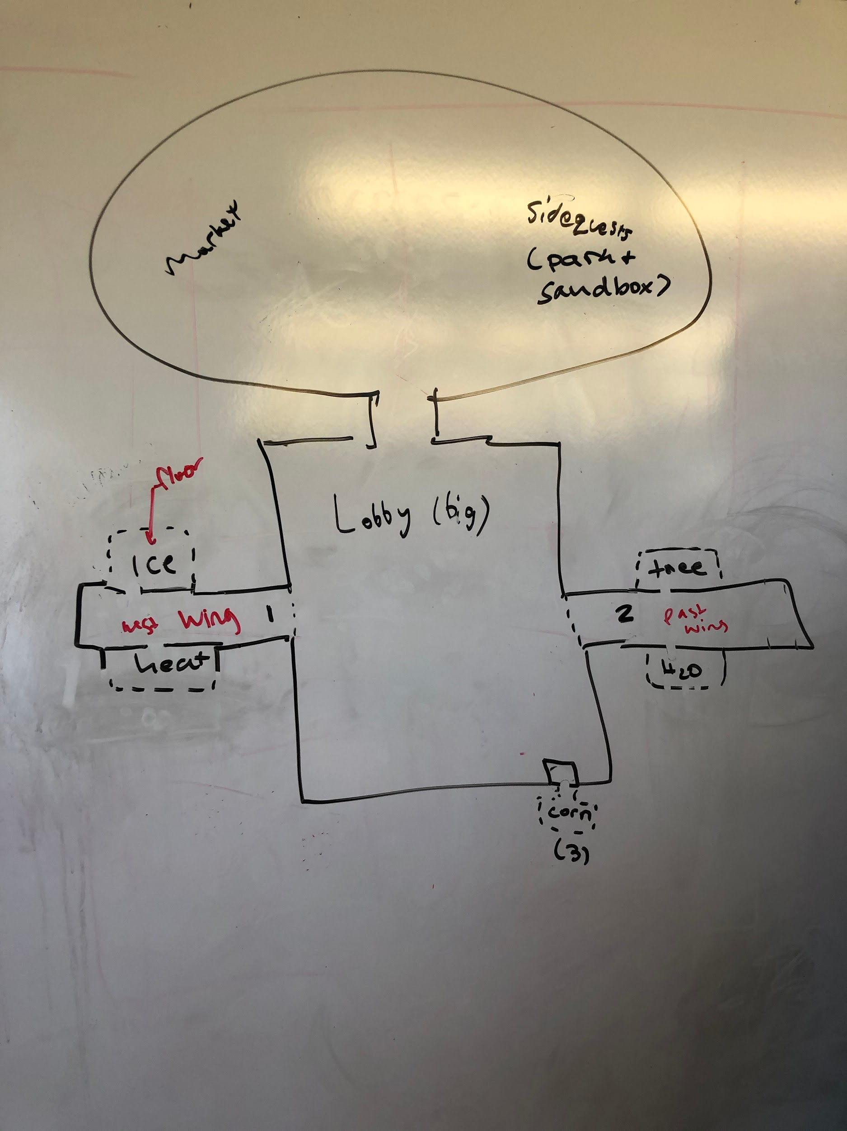

### Lobby/Start Location

The lobby doesn’t change over the course of the game. Visually elegant but homey, contains tables and chairs, reception desk, chandelier, and occasional human guests. Serves mostly as an access hub for wings and outside. Not necessary for character to return repeatedly to receive information–walkie talkie function allows player to automatically receive new assignments.

What’s There:

* Outside market and park accessible from lobby; outside quests are green man and mongolian death worm.
* Lobby gives access to wings and therefore elevators to floors.
* Key NPCs at reception desk for explanation and initial (tutorial) assignment
* Tutorial quest in hallway contiguous with lobby (redcap fight)

### Main Quest Rooms

Through the lobby, the player gains access to various floors, which are this game’s worlds. They each include:

* an **Exploration Floor**
* **Hotel Rooms** containing unique main quests and bosses

Each floor is themed differently, with bosses fitting to the theme

There is a total of **5 Main Floors** in the game (More will be added to the game in future classes. DLC at bottom of document.):

* **Floor 1C3** - ice world, home to yeti and yuki-onna
* **Floor H07** - desert world (hell world), home to thunderbird, mothman, chupacabra
* **Floor H20** - water world, home to kraken, sirens, Loch Ness monster, bunyip, jenny greenteeth
* **Floor 3** - forest/ tree world, home to bigfoot, jersey devil
* **CORN** - corn maze/ wisconsin world, home to hodag, scarecrow guy, wendigo

**Yule Cat** can be found in each exploration area to provide the player with sidequests that guide them **Hotel Rooms**

### Side Quests

Sidequests take place in **The Park** and in **Exploration Floors**. They aren’t in specific dungeons or anything, instead they can be done in the overworld.

* **Yule Cat** offers a series of sidequests in each world
* **Other NPCS** have one-off sidequests in exploration areas

### 

## Game Structure

### Monstel Structure

The hotel is divided into floors, opening up the player to more rooms as they get promoted/level up:

* Lobby acts as “safe zone” some exploration, access to outside park & desert (sandbox)
  + Outside is not safe, sidequests available
  + Lobby provides access to wings, wings provide access to floors, floors provide access to rooms
* Floors: Arctic, Desert, Water, Forest, Corn -- each contains 2-5 main quest rooms

Sketch of Lobby (just a sketch, not representative of actual design):

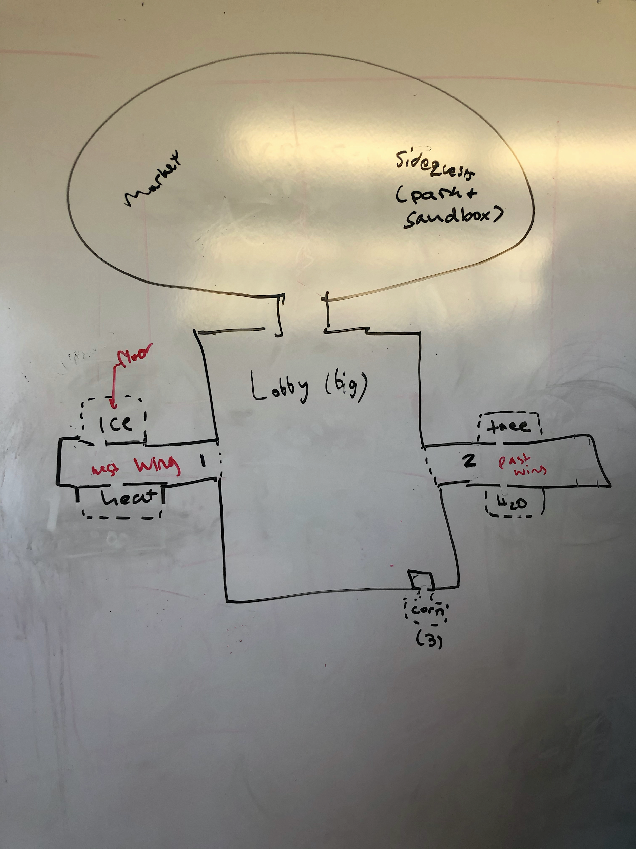

#### Lobby

The lobby acts as the hub world and safe zone. Players can interact with each other here and form parties, etc. There’s not a ton to do, but the player can access all of the floors and the outside from here. There are a few NPCS for the player to interact with, maybe providing some minor quests.

#### Outside

The outside area contains two main features:

**The Marketplace**,a series of market stalls where the player can buy, sell, and steal goods. This part of the outside area is safe.

**The Park**, an open space containing some sidequests and optional bosses. For example, this is where the player will interact with and complete sidequests for **The Green Man** and fight the Mongolian Death Worm, among other things. This will be expanded upon in the future. This part of the outside area is not safe.

#### Exploration Floors

Floors contain an exploration area that connects the lobby/elevators with the rooms in which main quests can be completed. Within exploration areas, the player can find items and random combat situations, with the combatants specific to each floor. Toward the far end of the space the player finds the doors to hotel rooms/dungeons that contain main quests. Sidequests, hidden items, and rewards for combat encourage players to return to past floors.

Sample exploration area (just a sketch, not representative of actual design):

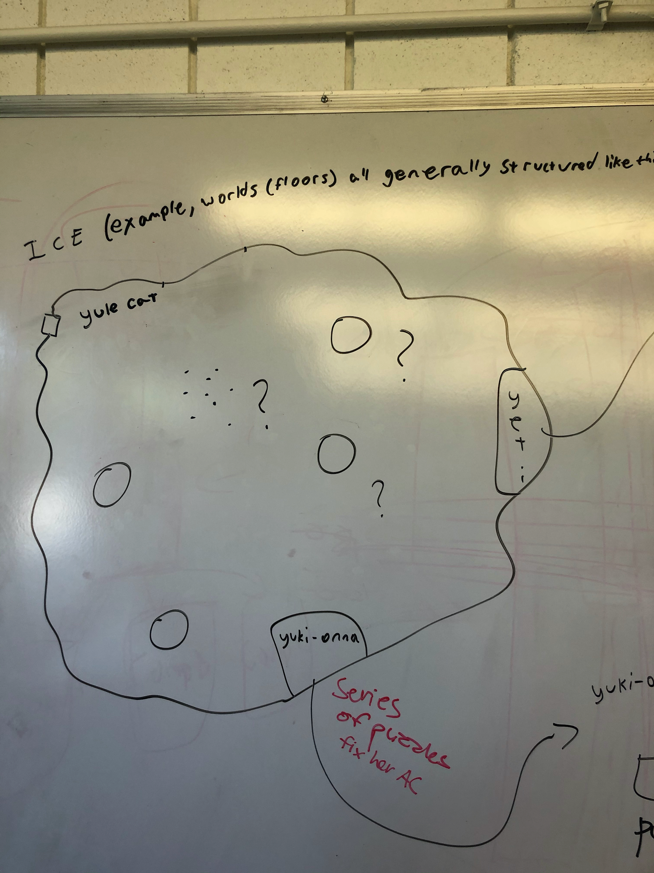

#### Main Quest Rooms

Main quests are mandatory and must be completed semi-sequentially, although there is some choice with regard to order within floors and wings. Dungeons/rooms consist of a series of rooms in various sizes in a maze-like configuration offering puzzles and combat situations. Room progression puzzles consist of several degree light traversal interactions to open up certain paths; these are not to be confused with boss puzzles, when completing the puzzle is the ultimate goal of the main quest. Each room ends with either a boss fight or a boss puzzle, and after completion of each room the player gains abilities or items. Completion of the final boss room of a WING leads to a promotion that gives the player access to a new area.

Sample main quest room (just a sketch, not representative of actual design):

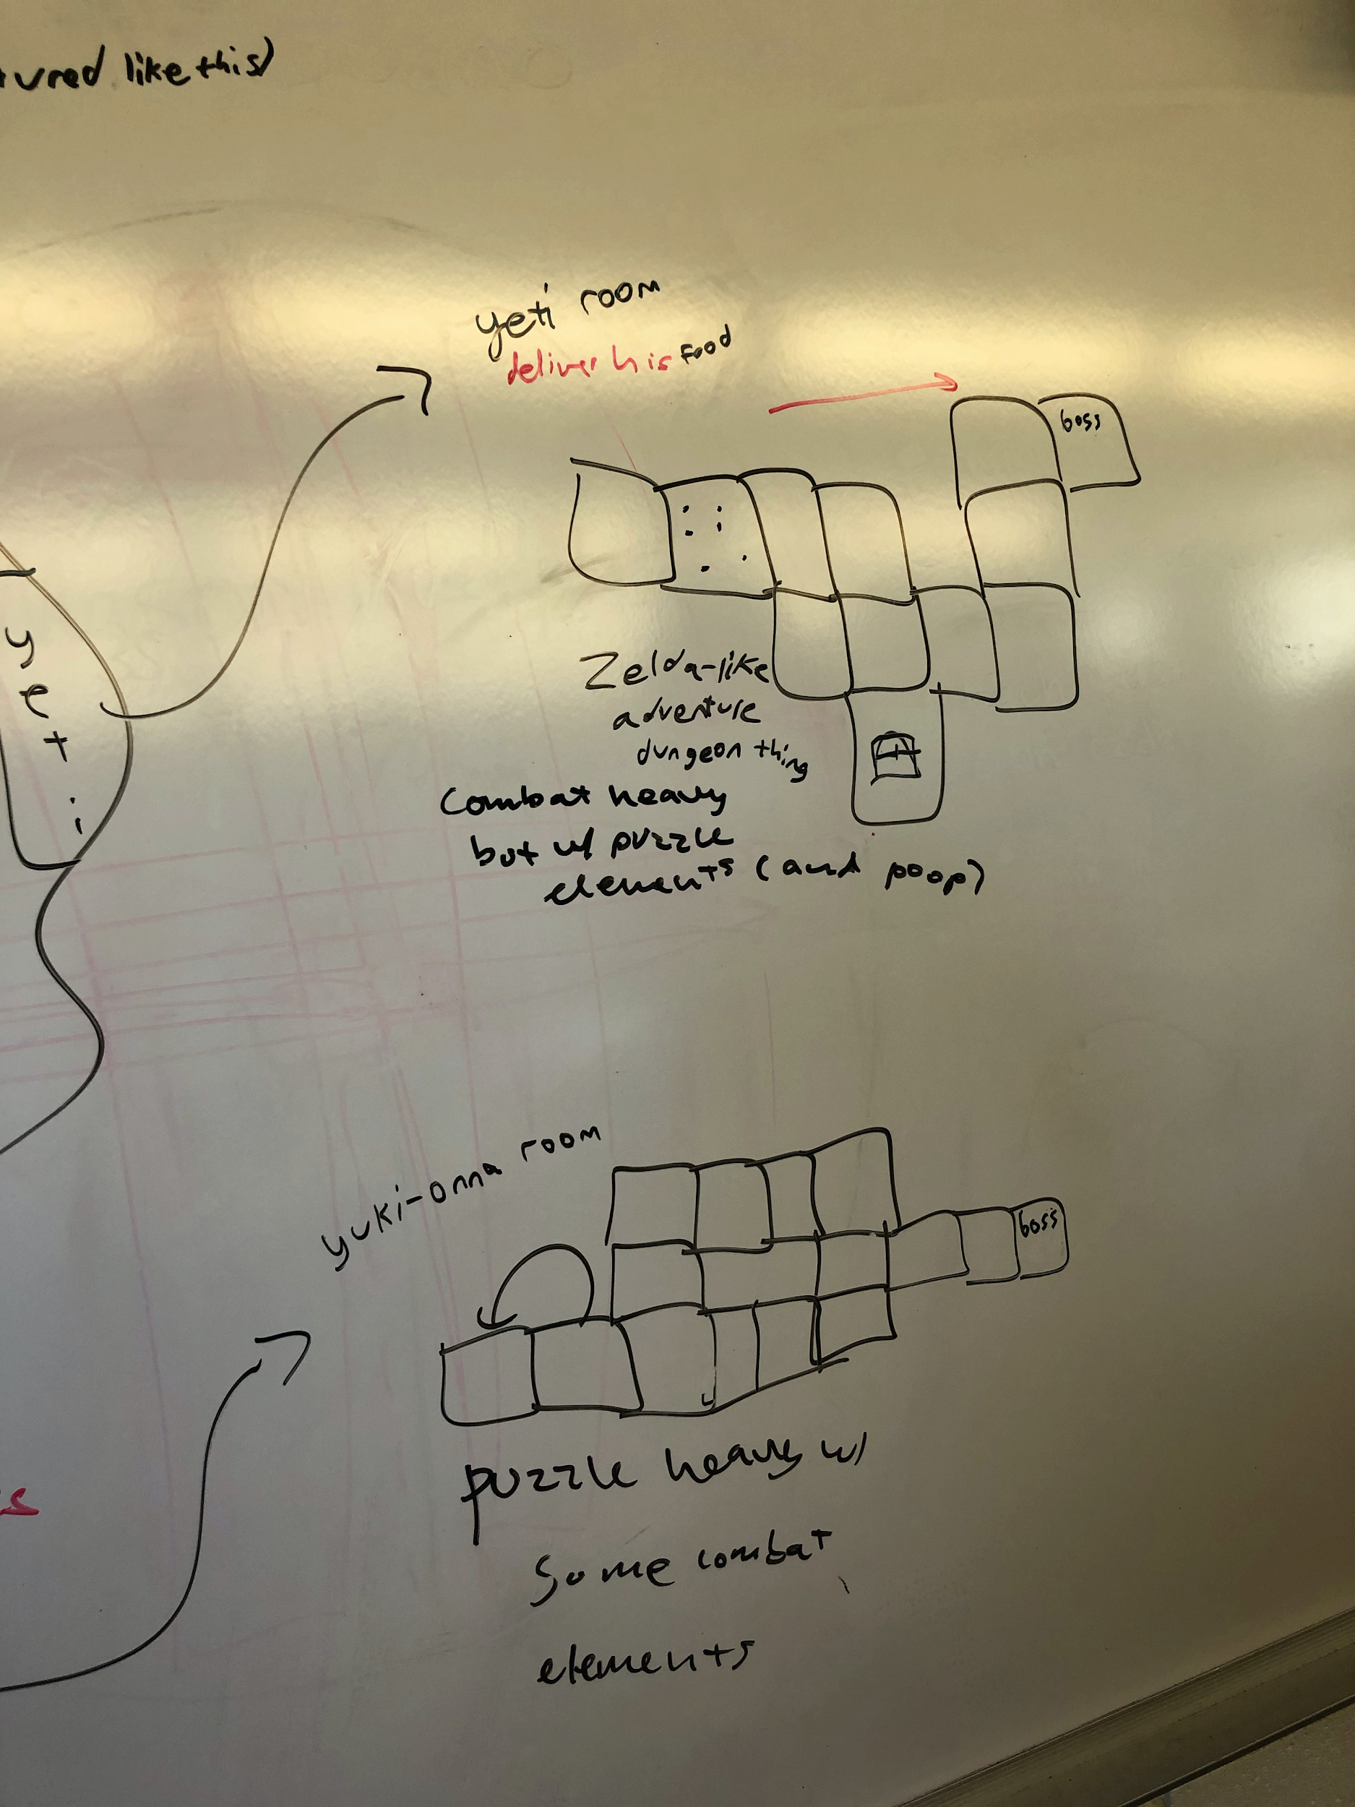

#### Side Quests

Side quests are optional mini-exploration areas, mini puzzles, or mini boss fights within floors and accessed via either exploration or interaction with an NPC (Yule Cat or floor-specific NPC). These are shorter in length and more condensed; challenge will vary (challenge and story value vary inversely?). Their main purpose is for the player to gain various point/money/item/ability benefits, as well as unique story experiences.

### Progression

Progression is gated to main quests’ completion. Once a room has been completed, the player is rewarded with an ability to access another room. Once a wing has been completed, the player receives a **promotion** and gains access to another set of floors (wing). Unlocking a new floor means the player has access to a themed elevator. The player will be able to see each elevator from the lobby, but their **keys** will only allow them access to unlocked elevators. Inside exploration floors, the players will be able to undertake sidequests, find items, fight monsters, and do other mmo things.

### Quest Replayability

Main Quest Rooms and Side Quest Rooms will be replayable. This is done so they can be replayed for MMO-level/item grinding , and so that quests can be replayed with friends. We could even randomize chests and stuff inside to encourage replaying quests.

## Game Loop

The gameplay cycles as follows:

* Move freely between the **Lobby** and the unlocked **Exploration Floors**
* Find **Main Quest Rooms** in **Exploration Floors** by completing quests on the route
* **Complete rooms by completing Boss Objectives (fighting, puzzles, etc.) to unlock a New Ability /** **Reward**
  + If exploration floor not complete, unlock new main quest room
  + If exploration floor complete, unlock new exploration floor

[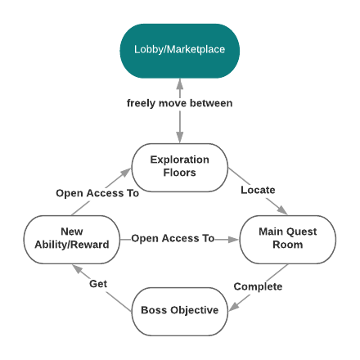](https://www.lucidchart.com/documents/edit/0e76d69f-b57f-4301-875c-8da88891d81c/0?callback=close&name=docs&callback_type=back&v=467&s=220)

## Character, Controls and Camera

### Characters

#### Characters’ Scale

The player will take up about 1/6 of the screen. NPCs and Enemies will be smaller or larger than a human depending on the character; some examples of this are reflected in concept art.

### Controls

#### Control Scheme

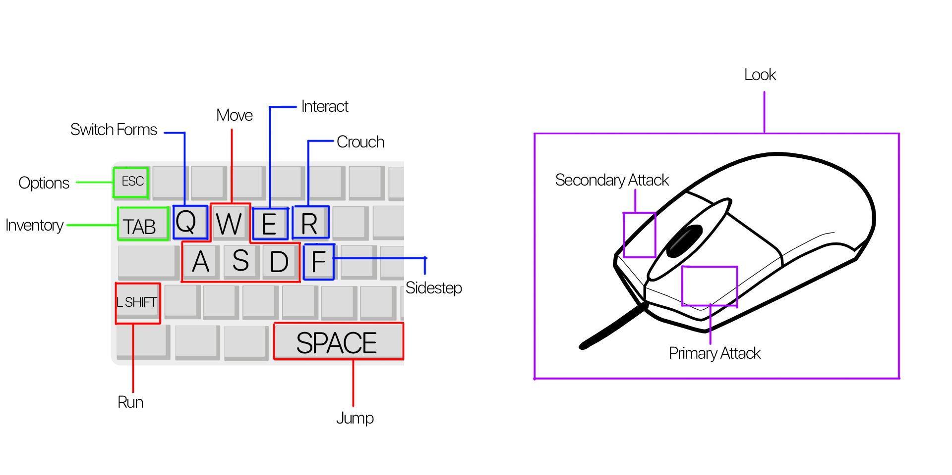

### Camera

The camera is third-person and will be controlled by the mouse. The player will always be at the center of the screen and the camera will rotate around them at a mostly fixed distance, zooming in and out dynamically to avoid strange clipping issues with walls. If the player is scoping with a bow, then the camera will zoom in to first person to help aim. The camera will then return to third person when the player has fired the weapon.

## Systems

### Traversal Systems

#### On the ground

By default, the player can:

* **Walk** - basic movement with WASD.
* **Run** - faster movement while holding shift.
* **Crouch** - makes the player stealthier, lower to the ground, and slower (toggled with R).
* **Jump** - it’s a jump. press space.
* **Sidestep** - quick dodge with short cooldown when F is pressed. Only useful for combat.

At set points in the story, the player will unlock the **Thunderglide** and **Another Unnamed Ability:**

* **Thunderglide** - *work in progress*
* **Other Thing** - *work in progress*

### Combat Systems

Similar to traversal, the player can fight in either their human or cryptid form. As the human, the player will be able to switch between weapon types (collected during gameplay) from their inventory, equipping one as a primary and one as a secondary. In cryptid form, the player can attack using a predefined primary and secondary attack as well as combat abilities earned through levelling up. Cryptids will also have special abilities mapped to 1234.

#### Offensive moves

##### Physical Attacks (Human and Cryptid)

Physical attacks can be both primary and secondary attacks for either form. They each have a basic 3 hit combo from 3 clicks in a row. Clicking a fourth time will go back to the first attack with a slight delay.

There are two types of physical attacks:

* **Light Melee** - Human daggers, Werewolf and Nagual primaries. These attacks are faster and do less damage. Shorter delay between attacks.
  + *Example Sequence:* for a human, a swipe one way, a swipe the other, then a spin
* **Heavy Melee** - Human longswords, Cryptid secondaries. These attacks are much slower but do more damage. Longer delay between attacks.
  + *Example Sequence:* for a human, a slash up, a slash down, then a thrust

For heavy attacks, the player can also hold down the attack button to charge. Some particle effect will show the player that the attack is done charging, and when released will do damage.

##### Ranged Attacks (Human and Selkie)

Ranged attacks can be primary or secondary for humans. A light ranged attack is the Selkie’s primary. These do not have combos, but a short delay between attacks.

There are two types of ranged attacks:

* **Light Ranged** - Human crossbow, Selkie primary. Fast attacks that don’t do a ton of damage but not a ton of cooldown.
* **Heavy Ranged** - Human bow. These attacks are slow and require a bit of charging. More cooldown, but more damage and more precise.

##### Defensive Moves (Human and Cryptid)

Defensive moves take the form of shields and sidestep:

* **Shields** - exclusive to humans and can be equipped as either primary or secondary. These only block (maybe later we’ll implement some kind of parry mechanic?).
* **Sidestep** - can be done by either human or cryptid. All this does is move the player quickly out of the way. Heavier cryptids will have slower sidesteps/cooldowns

#### Special Moves (Cryptids)

Each cryptid will have 4 combat special abilities mapped to 1234. These attacks will have a cooldown between uses.

##### Werewolf

* **Excalibur Slash** -- induce bleed (damage over time)
* **Family Game Night** -- summon puppies to attack enemy OR turn enemies against each other
* **Moonstruck** -- induce blind (enemy won’t be able to find player)
* **Lick Wounds** -- self heal

##### Nagual

* **Dream Peck** -- induce sleep
* **Hidey Hole** -- invulnerability while head is in ground
* **Mega Kick** -- lots of damage
* **Suck It, Darwin!** -- self-explanatory; big boy jump

##### Selkie

* **Siren Song** -- induce confuse
* **Holy Water** -- minor team heal
* **Slide Rush** -- dash attack
* **Splish Splash** -- area of effect (aoe) attack

### Life Management

#### Recovering health

The player has two ways of recovering health:

* Whenever the player returns to the lobby, their health will be fully recovered (by consuming mints from the front desk)
* In levels, the player can recover by using health consumables

Consumables are various medicines. They can be purchased in the market and occasionally found around exploration areas (like the items you find around in Pokémon). As the player progresses, the consumables they collect will be more powerful.

#### Respawning

When you die, the green man makes fun of you with some brief text. If the player is playing alone, they will respawn with full health at the start of the area (or the last checkpoint if in a dungeon).

In a party, players can revive each other in cryptid form. This is done by standing on the dead body in cryptid form and waiting for a set amount of time. The process is sped up if more players are standing on the body. If everyone dies, the whole party is sent back to the start of the area (or the last checkpoint if in a dungeon).

### Upgrade System

Still a work in progress. Tied to level completion, fighting monsters, etc.

### Items

**Item Types**:

* **Consumables** -- Health, Food, Medicine
* **Equippables** -- Weapons, Clothing
* **Key Items** -- Puzzle Components, Keys, Quest Items, etc.
* **Ingredients** -- Fruit, Fish, etc.

#### Consumable items

Consumable items take the form of health (medicine) and temporary buffs (food). Medicine, as explained above, can be found or purchased from the shop. Food is acquired only through cooking ingredients and provides temporary powerups to the player. For example, the player could cook a dish using apples to get a consumable item that gives the player increased attack for three minutes. Consumables will be equipped to the 3 and 4 slots on the **Human**.

#### Equippable Items

Weapons and Clothes are collected as rewards/treasure from quests or purchased from the shop

* Weapons (you have them in an inventory display and during fights they’re easily accessible; get them through shop/collect; controlled using mouse)
  + Range weapons (crossbows, regular bows)
  + Melee weapons (long sword, dagger, spoon)
  + Shields
* Armor
  + Different armor classes--you get better armor as you go along and the game gets more challenging
  + Maybe they have protection from certain attacks (like fireproof or blunt-force-trauma-proof)
* Clothing (collected through stealing/ buying from market)
  + Keep you warm
  + This could factor into customization of character

#### Key Items

Key items will be given to the player during quests. These cannot be traded or sold, and the player can’t use them for anything other than their single function.

#### Ingredients

Ingredients can be collected in exploration areas, similar to ingredients in Breath of the Wild. These can be used to cook food or can be sold in the marketplace for a small amount of money. Basic ingredients can be purchased from the marketplace as well.

### Cooking

Using ingredients collected in the wild, the player will be able to cook in the hotel kitchen, accessible from the lobby. Cooking will function similar to the way it does in Breath of the Wild: the player will choose a few ingredients to cook and will be rewarded with a temporary stat buffing consumable (**food**).

The minigame is a series of button mashing and quicktime events, and the player will be rewarded with a higher tier version of the food item the better they do in the minigame.

### Fishing

The fishing minigame is accessed in **Floor H20** and is like a simpler version of the Stardew Valley fishing game:

* The player casts a line and presses a button to begin the game
* The player will hold down a button while the fish icon is in a certain range, filling up a meter when it’s done correctly
* Once the bar is full, the minigame ends and the player collects the fish
* The player loses if the bar runs down to empty.

The player sell caught fish in the marketplace or use them for cooking.

### Monetary System

#### Sources of Income

The main source of income for the player will be **tips**, the rewards for missions. The player will also receive a daily **salary**, which they will receive upon logging in for the first time on a new day. The player can also steal certain objects from shops or npcs, which they can then use or sell in the marketplace.

#### Currency and Exchange

The main currency of the game is **Euros**.Items are bought and sold at standardized prices in the marketplace.

### Save System

#### Save Logic

The player will start in the lobby each time they load up the game. They can save whenever, but there is no autosave. The player has to manual save and, and we need to make this clear. Dungeons have checkpoints where you can respawn so you don’t have to start the whole thing over again.

## Enemy Design

Enemies all come with a set of stats, of which health (hits taken), damage, and speed (ranged or melee) are the most important to defining how challenging the enemy is. Enemies have a health bar (not numbers, though). Pest-type enemies spawn in certain parts of exploration areas and dungeons. Ultimately it will be possible to defeat any enemy in any mode, but certain enemies will be easier to attack in certain ways (encouraging strategy with the modes–for example, a nagual player may want to fight a heavy-hitting enemy as a human with ranged weapons) and enemies in higher levels might not be defeatable using early weapons (ex. the spork). There are 1-2 pest-type enemies on each level, for a total of 8 pest-type enemies; guest-type (boss) enemies vary.

### Enemy Types

* Heavy-hitting
* Fast and samll
* Projectile-slingin’
* Sheilded

In general, pest-type enemies will be aggressive toward the player and actively attack when the player enters their range / line of sight. An enemy will attack by briefly telegraphing, swinging/shooting once, then waiting a set cooldown to attack again. Enemies with shields will be able to block player attacks until they are broken/knocked out of the way/something.

## In-Game User Interface

The game interface is composed of the following elements:

* Current objective
* Compass
* Health
* 1234 bar
* Equipped weapons

## Inventory

The inventory interface is composed of the following elements:

* Equippable slots (on the left)
* Items (on the right)
* 5 tabs:
  + Consumables
  + Weapons
  + Clothing
  + Key items
  + Ingredients

To move things in the inventory, click the items and then click slots to move.

Player has limited consumables/weapons/clothing inventory space (default X slots) and can purchase more in the market. Key items and ingredients space is unlimited.

## Menus

### Options Screen

Allows the player to access various options sub-screens as well as leaving the current game:

* Keybindings
  + Edit, Return to default
* Volume
  + Specifics
* Save
* Quit
* Return To Game
* Screen Options
  + Size, Fullscreen, Brightness

### Map screen

Press M on keyboard to access the map in a pop up screen. There’s a marker showing you where you are and you can place markers in places of interest; there won’t be a specific “go here” on the map, but there will be prompts from npcs so that the player knows where to go and can mark the location on their map. There’s a compass on the map and in general always visible during gameplay.

At the bottom of the map screen will be the player’s current active quest. By clicking a button to go to another page, the player can view all current accepted quests and change which one is active. (see also: cat quest 2 map)

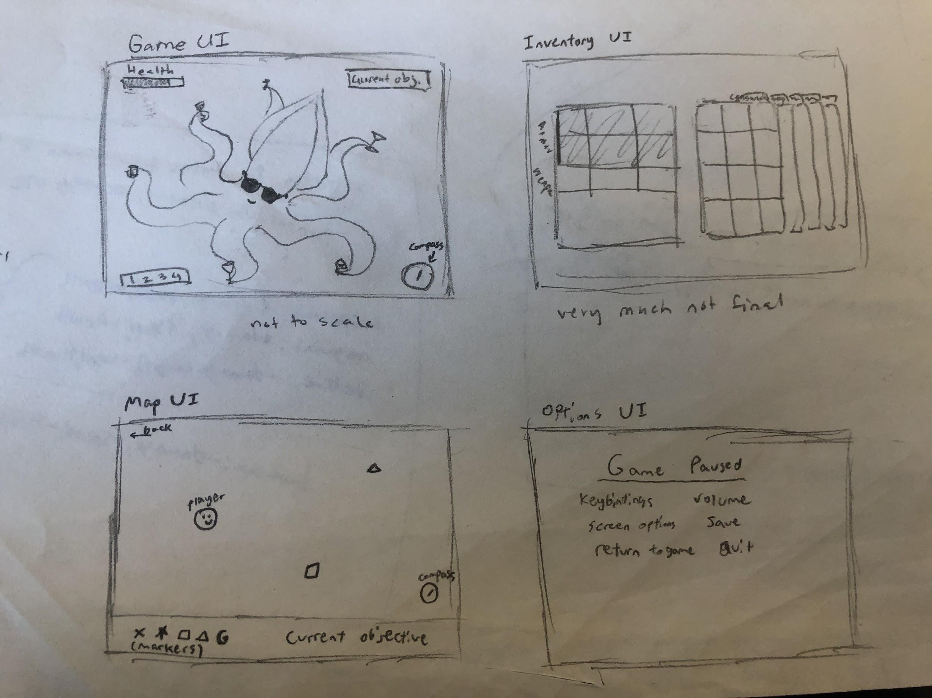

## Story Telling

### Dialogue System

The story is told through a combination of dialogue and plot elements. The game does have voice dubs, and characters should have a set of simple animations to perform while talking.

Interacting with specific objects should bring up a dialogue box if they contain text. The dialogue system could also be used to give characters choices (STEAL or DON’T STEAL), since these decisions would impact progression in the same way certain dialogue choices would and would impact ultimate wendigo health in the same way.

## DLC / Future Content

There are a few ideas regarding how to expand on the game beyond the final boss in years to come. One idea is to reveal to the player that there is a network of other hotels, and future floors / content will take place in other very similar looking hotels. Another idea is to just give the hotel infinite floors, and just create more storylines to take place in the same hotel.

### Future Ideas

These are ideas for future iteration:

* Exchange Rate Shenanigans: Each floor could have a different kind of currency and they would all have weird exchange rates between each other to mess around with in the marketplace
* Mounts: The player could maybe get like horses or something to ride